SafeREVERSE
Sonar ®

MANUAL

OPERATION MANUAL

Thank you very much for choosing the SafeREVERSE Sonar® Ultrasonic Reverse Collision Warning System. In this manual, methods of how to use and install the device are described and clearly illustrated in detail. Review the manual thoroughly for proper installation procedures and familiarize yourself with its capabilities and correct usage for your driving safety.

If you have any questions with regard to installation or service, please call your SafeREVERSE Sonar® retailer for complete assistance.

Thanks again for choosing the SafeREVERSE Sonar® and enjoy safe and responsible driving.

CONTENTS

SECTION 1: PRODUCT INFORMATION

SECTION 2: INSTALLATION

SECTION 3: PRECAUTIONS

Please Note:

The sensor wires cannot be cut or altered in any way. Their resistance will be altered as well as their accuracy and any warranty is voided.

2.The electrical impulse wires (wires to the tail light and to the buzzer) can be cut or more wire can be added for length and position convenience.

SECTION 1: PRODUCT INFORMATION

1. | Voltage | DC 12V
2. | Temperature | -20 º C to 60 º C
3. | Usage | Sensing for objects or obstacles at  the rear of the vehicle when backing up
4. | Principle | Distance is measured by using ultrasound waves
5. | Operation | The SafeREVERSE Sonar device is wired into the vehicle’s back-up light circuit, and is automatically powered and turned on only when the vehicle is shifted into reverse. only if there is an object behind the vehicle, the sensors detect the object and its distance and bounce signals to the control unit which then activates a three (3) stage audio warning beeping tone in the vehicle near the driver. This alerts the driver to the unseen object behind by emitting a series of different beeps dependent upon the distance from the object.
6. | Parking Assist | Place transmission in reverse  Back up very slowly  Apply brake and stop when the buzzer tones are changed gradually into continuous ones.  Check object behind, drive forward to  position vehicle closer to curb and repeat procedures above until vehicle is parked safely.

TYPE AND RANGE OF SIGNAL

Distance  (from object) | Alarm Sound | Description
@120 cm | beep-beep-beep | Long term between signals
@80 cm | bp-bp-bp-bp-bp | Short term between signals
@50 cm | beeeep............ | Continuous signal tone

HORIZONTAL

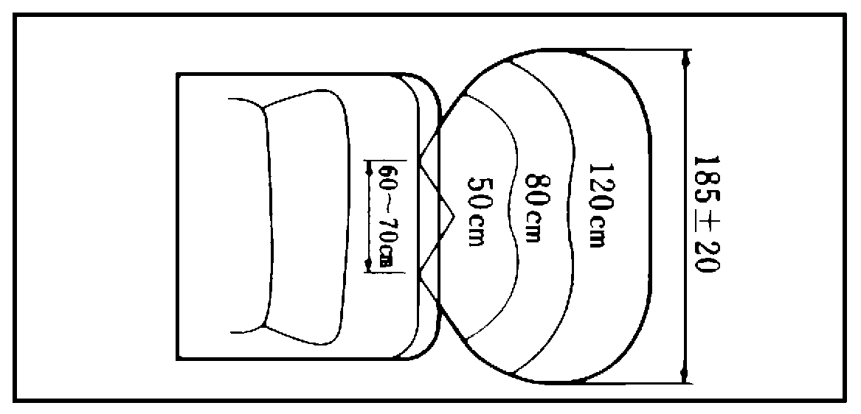

VERTICAL

SECTION 2: INSTALLATION INSTRUCTIONS

OVERVIEW

Voltage requirement is 12 volt DC. This device uses the principal of ultrasound to sense for any obstacles at the rear of the vehicle while backing up.

When the vehicle is shifted into reverse gear, power from the back-up light connection is transferred immediately to the ultrasound sensors attached at the rear of the vehicle. It then begins to detect any objects, if any are present, up to the approximate distance of four (4) feet or 120 cm.

As it “senses” any obstacle ( toys, child, post, car, etc.) behind the vehicle, the driver is alerted by a series of ‘beeps’ from the buzzer which is situated in the vehicle near the driver’s area. This is not the beeper system commonly used to warn people outside the vehicle to get out of the way of a reversing vehicle.

As the vehicle approaches closer to the obstacle, the buzzer beeps faster until it becomes a continuous beep when the vehicle is 20” or 50cm. away from the obstacle.

When the SafeREVERSE Sonar is operating, advance warning of any potential collision is given to the driver and assists the driver to avoid unnecessary accidents. However the SafeREVERSE Sonar does not relieve the vehicle operator of any responsibility for using normal precautions when reversing their vehicle. It is to be utilized as a reversing aid and is entirely supplemental to safe driving procedures.

INSTALLATION

STEP 1…..Prepare locations for the sensors

- Find locations on either side of the vehicle that will give protection to the sensors but will also allow the sensors to have unobstructed view of the ‘field’. Clean the selected area.

- Attach the sensors to the selected locations while ensuring that the sensors will be:

(a) approximately 60 - 70 cm. from the ground.

- parallel or at right angles to the ground. This will avoid false signals from the road surface. Installer can unscrew at the rear of sensor and allow thick part of base and wire to face downward to ensure right angle signals.

Examples of angle adjustments


(#1)
Examples of angle adjustments (cont’d)

(#2)
- positioned close to areas that can conceal sensor wiring from view and/or near areas that wire can be inserted or where a hole can be drilled for threading sensor wires through to trunk or van box.

STEP 2 ..... Attaching the sensors

- Attach the double faced tape on the rear of the sensor after all position adjustments have been made.

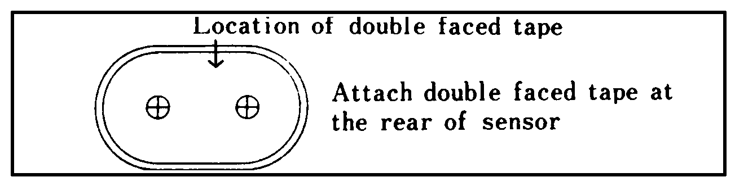
- Put rubber covers onto the base and attach horizontally to the selected locations at the rear of the vehicle.
Please Note: The sensor wires cannot be cut or altered in any way. Their resistance will be altered as well as their accuracy and any warranty will be void. The electrical impulse wires (wires to the tail light and to the buzzer) can be cut or more wire can be added for length and position convenience.

STEP 3 ..... Wiring the sensors

- Insert sensor wire(s) between light covers or pre-determined drilled holes and thread into ‘trunk’ area.

- Attach sensor wires to the ECU or Electronic Control Unit. There are four (4) male sockets on the control unit ---- #1 for the power wire, #2 for the buzzer and #3 and #4 for the sensor wires. (#3 & #4 connectors are interchangeable)

- Place and attach ECU box in a protected area in the trunk and protect from all elements. Secure loose sensor wires with cable ties. Ensure box and wires are secure and placed where no traffic, stored items or movement will cut or crimp the wiring.
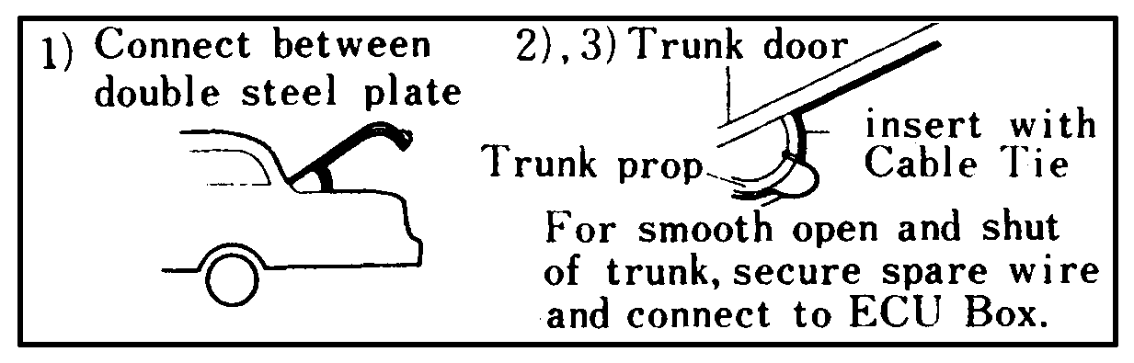

STEP 4 ..... Connecting power

- Attach the ECU power wire as follows:

(a) connect the positive wire (white) to its counterpart wire (positive) at the reverse or back up light.
- connect the negative wire (black) to its counterpart (negative) at the reverse or back up light or connect to ground.

(c) connect the 2 pin wire connector of the power wire to the proper ECU fitting which is the #1 socket. This socket (white) is the first connector from the left hand side when the ECU box is in an upright position and the connector side is in view.

STEP 5 ..... Placement/attachment of ECU unit and buzzer

- Attach units with double sided tape; place the ECU unit in a protected place away from possible abuse and position the buzzer in the driver’s area in a place that the signal can be heard clearly.

STEP 5 ..... cont’d

- Plug in the 2 pin buzzer wire into the ECU unit in the appropriate #2 socket (2nd from the left). The SafeREVERSE Sonar is now ready to help the driver back up more safely than ever before.

STEP 6 ..... Testing the unit

- After installation, move the vehicle to an area where there is no obstacle within sensing range of the SafeREVERSE sensors.

- Start the engine and place transmission in reverse. The buzzer will beep once to indicate that unit is operating.

- Back the vehicle slowly towards an obstacle and the first series of intermittent beeps will be heard when the vehicle is within 120cm of the obstacle.

- As you move closer, in reverse, to the obstacle, the beeping will become more rapid until a steady beep is heard when the vehicle is within 50cm of the obstacle or closer.

The sensor wires cannot be cut or altered in any way. Their resistance will be altered as well as their accuracy and any warranty is voided.

The electrical impulse wires (wires to the tail light and to the buzzer) can be cut or more wire can be added for length and position convenience.

SECTION 3: PRECAUTIONS AND TROUBLESHOOTING

In case of incorrect operation or malfunction of the unit, please check the following possible causes:

1. Ultrasound waves can be absorbed by materials such as cotton, some textiles, sponge and snow. Make sure the sensors are clean and free of any such material.

2. If ice builds up on sensor, possible malfunction could occur. Wait until temperature rises (inside parking, weather, etc.) and ice will melt. Sensors will function as before.

3. If sensors become clogged with mud or snow and their sensing is interrupted, clean the sensors with a soft cloth.

4. Loud radio volumes will interfere with the driver’s hearing of the warning beeps.

5. The accuracy of the unit is affected adversely when it is operated at temperatures above 60 º or below -20 º C.

6. Make sure no accessories are attached within the scope or range of the sensors

7. Irregular alarms may occur due to reflection of ultrasound by pebbles or by reversing down a sloping driveway.

LIMITED WARRANTY

Global Accents Ltd.’s sole liability for any defect in the SafeREVERSE Sonar unit (the “Product”) shall be the replacement of same during the One (1) year warranty period.

Global Accents Ltd. shall have no liability for any damages or personal injury resulting directly or indirectly from the use of the SafeREVERSE Sonar (the “Product”) or from any defect in same. The Purchaser, by installing and using this device, hereby releases Global Accents Ltd. from any liability for damages to property injury resulting from the use of the Product.

Never rely solely on SafeREVERSE Sonar for back-up collision avoidance. Remember the principal of this safety enhancement device is that you immediately stop your vehicle upon any warning, and then clear the obstruction behind you before continuing to back-up. The SafeREVERSE Sonar system does not relieve the driver of any responsibility for safe backing or reversing. It is an aid and entirely supplemental to safe driving procedures.

